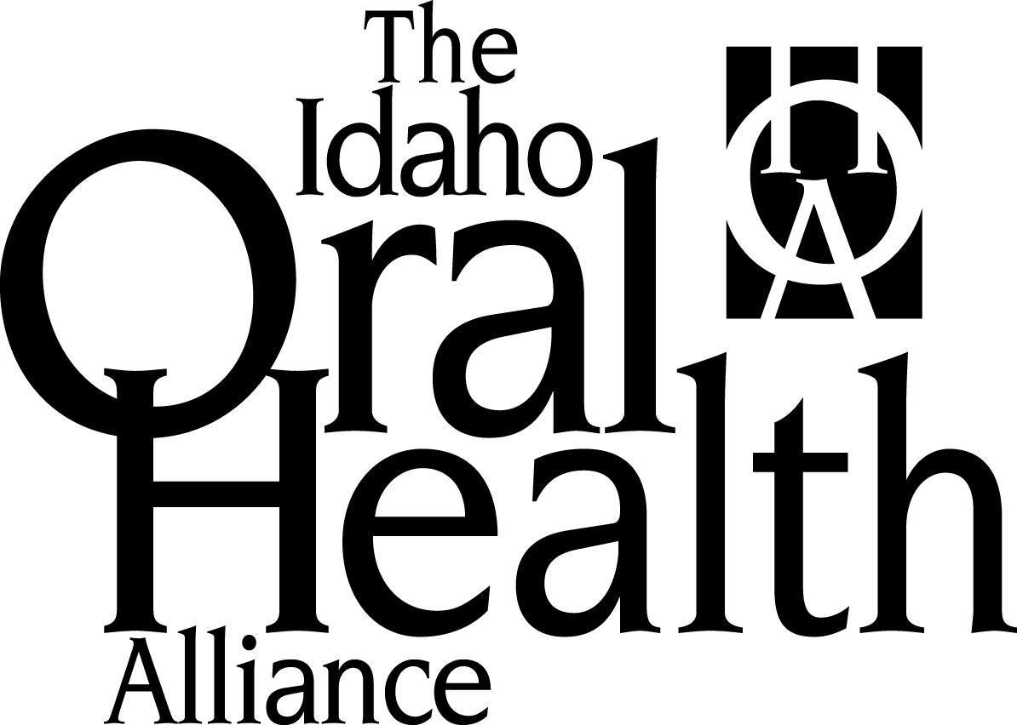

For Immediate Release Contact: Jennifer Wheeler
October 5, 2015 208-994-9058 jwheeler@idahooralhealth.org

Idaho Oral Health Alliance Director Appointed to Idaho Healthcare Coalition

(Boise) – Governor C.L. “Butch” Otter has appointed Jennifer Wheeler, executive director of the Idaho Oral Health Alliance, to the Idaho Healthcare Coalition (IHC).

The IHC was created in February of 2014 by executive order of the Governor to oversee the implementation of the State Healthcare Innovation Plan (SHIP) to develop a patient-centered model of care that “focuses on improved population health, improved individual health outcomes, and cost efficiencies.”

The Idaho Oral Health Alliance (IOHA) is a uniquely positioned statewide nonprofit that leads communication and collaboration among a diversity of stakeholders to improve the oral health of Idahoans. As the representatives for oral health on the IHC, Wheeler and the IOHA are creating an advisory committee to help craft recommendations as to how oral health could be included in the SHIP.

Wheeler joined the Idaho Oral Health Alliance (IOHA) in August 2014 as the first-ever staff person. The IOHA also leads the efforts of the Healthy Me is Cavity-Free Collaborative – a statewide group of oral health professionals and youth educators who are working to find ways to prevent caries for children 0-3 with educated caregivers.

For more information about the IOHA, visit http://idahooralhealth.org/

##

